IN26012154

Assignment — Implement Authentication & Authorization

Student Registration Web App

ASP.NET Core 8 MVC · Entity Framework Core · ASP.NET Core Identity

Name: Akhil Astitva
Application No.: IN26012154
July 2026

StudentRegistration WebApp
Authentication, Authorization, and Role-Based Navigation in ASP.NET Core Identity
Comprehensive Technical Documentation & Source Code Submission

1. Executive Overview & Technology Stack
This project is an end-to-end ASP.NET Core MVC web application called StudentRegistration. It provides secure user authentication, role-based authorization (Administrator & Student roles), and dynamic navigation menu customization using ASP.NET Core Identity and Entity Framework Core.
Key Technologies Utilized:
• Framework: ASP.NET Core 10.0 (Model-View-Controller)
• Security Engine: ASP.NET Core Identity (Cookie-Based Authentication & Role Authorization)
• ORM / Data Layer: Entity Framework Core 10.0 with SQL Server Provider
• Database Engine: Microsoft SQL Server (SQLEXPRESS)
• Front-End UI: HTML5, CSS3, Bootstrap 5, Bootstrap Icons, and Glassmorphism Custom Styling

Part A: UI Navigation Screenshots & Database Schema

1. Administrator Navigation
Shows top navigation bar for logged-in Administrator displaying links: Home, Courses, Students, and Logout, alongside the admin email (admin@studentreg.com).
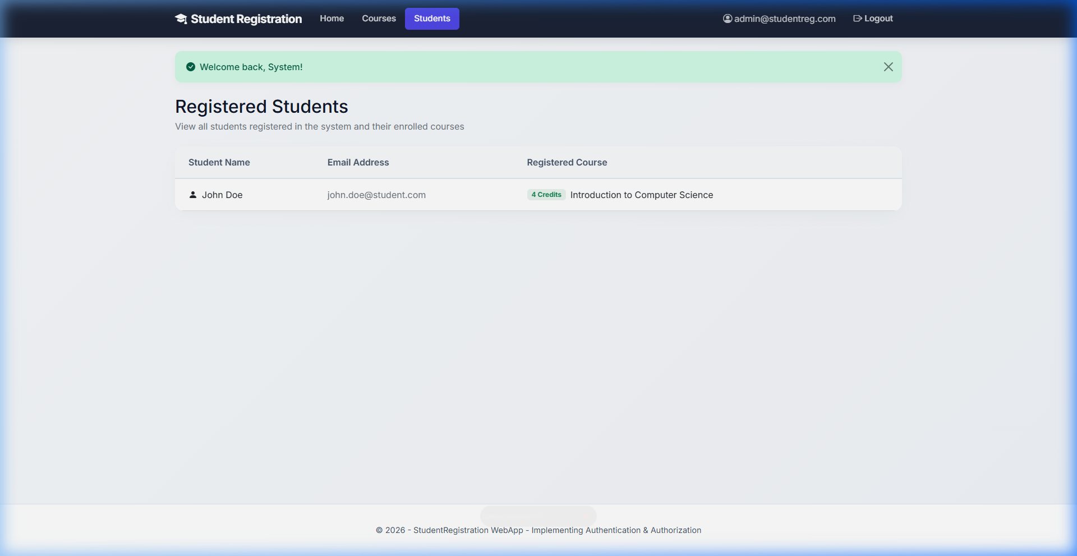

2. Student Navigation
Shows top navigation bar for logged-in Student displaying links: Home, Courses, My Profile, and Logout, along with the student email (john.doe@student.com). Notice 'Register for Course' link is automatically hidden after enrollment.
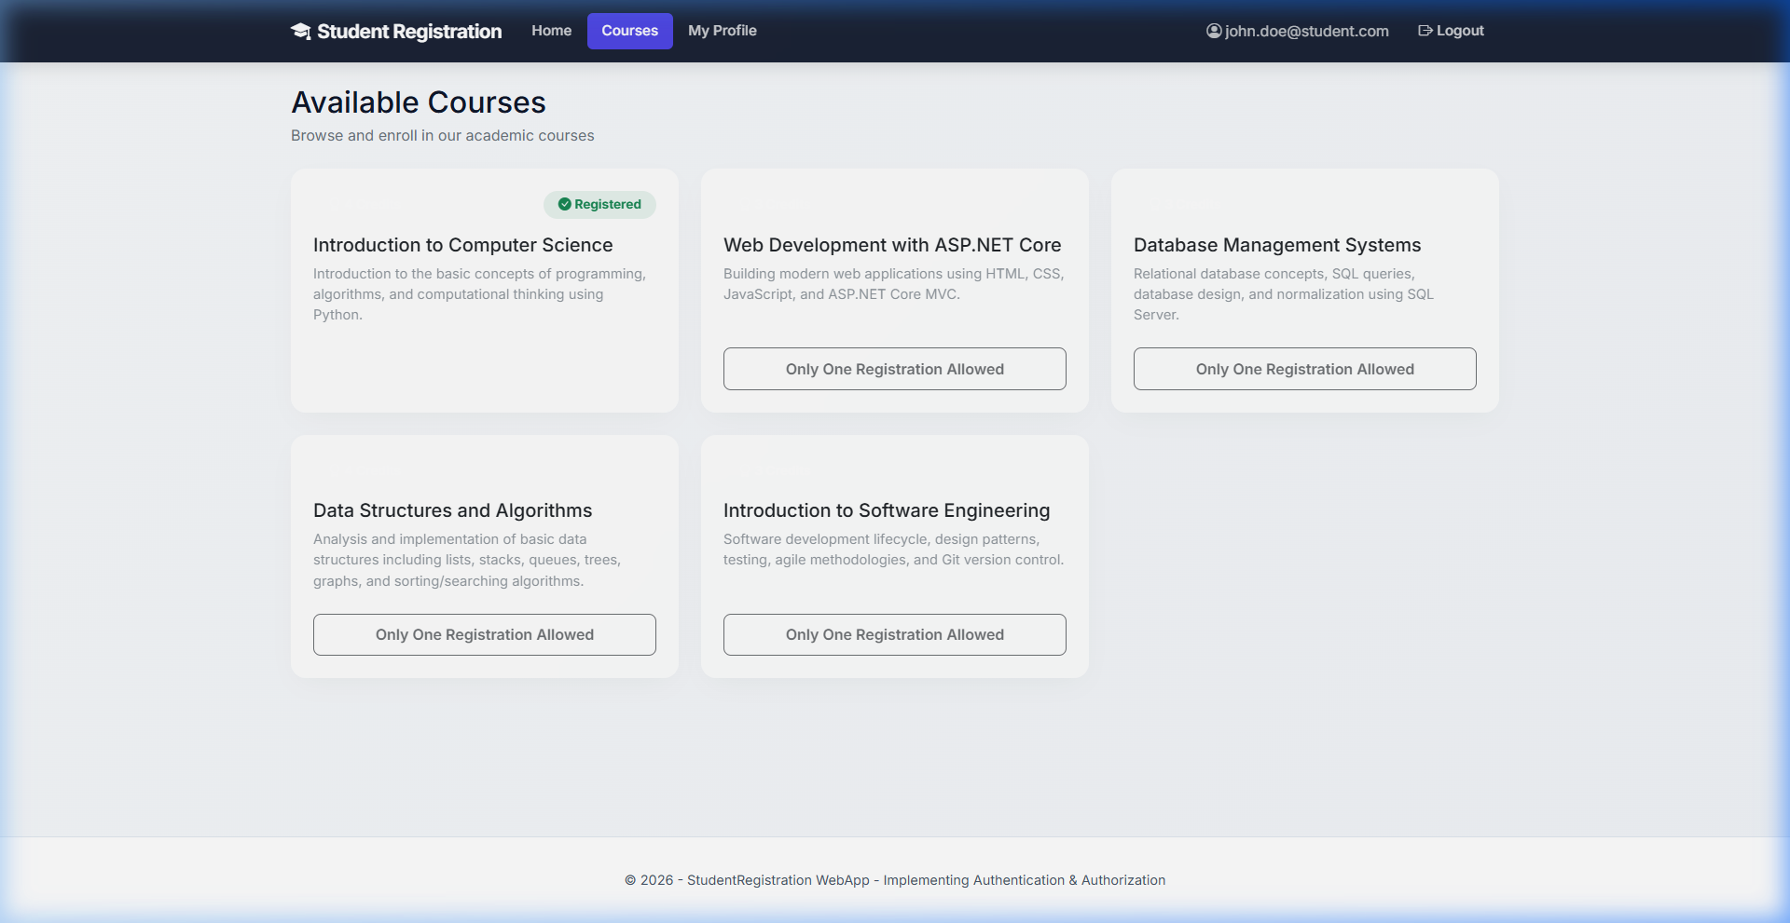

3. Anonymous Navigation
Shows navigation menu for unauthenticated (Anonymous) users displaying links: Home, Courses, Register, and Login.
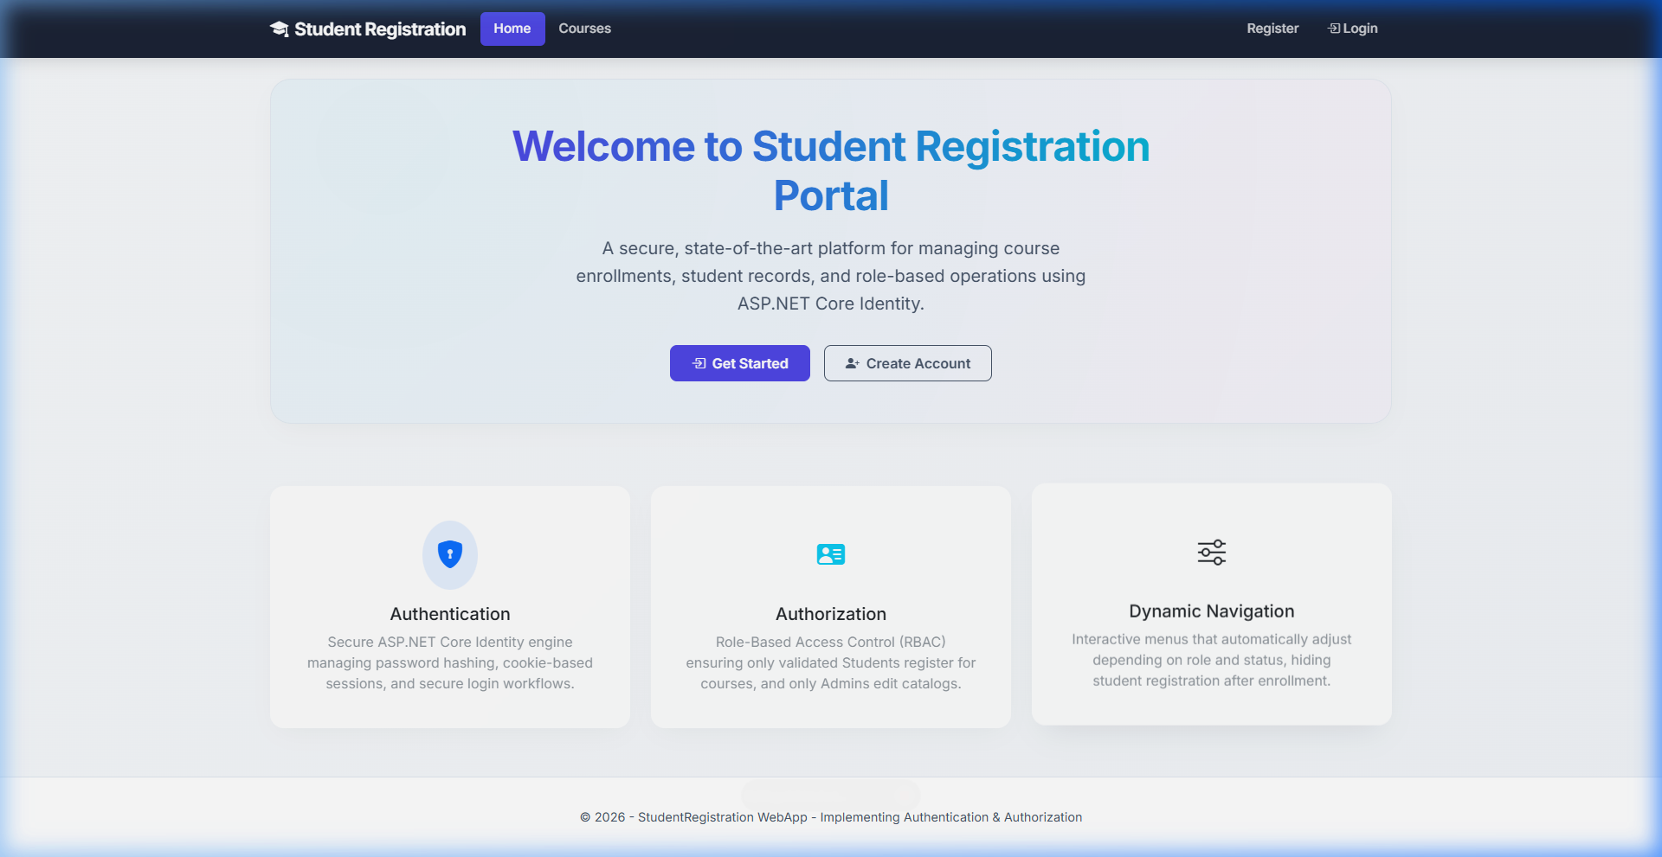

4. Successful Login
Displays the welcome alert banner after successful authentication, showing 'Welcome back, John!'.
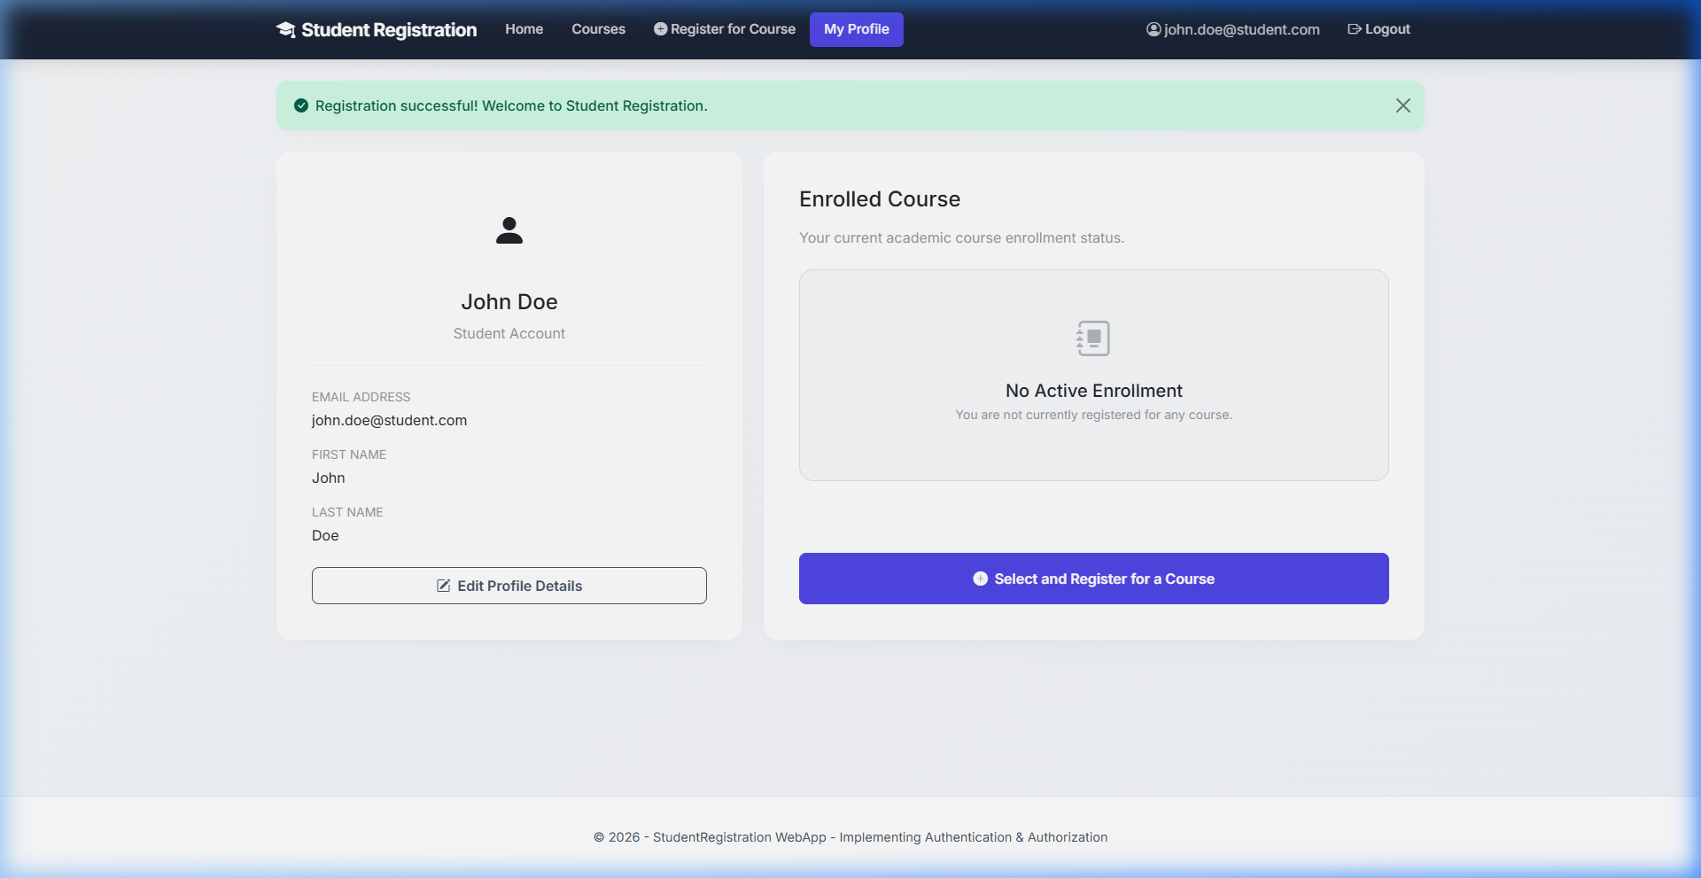

5. Successful Course Registration
Displays successful registration confirmation banner and updates the course badge to 'Registered' with button disabled to enforce single course enrollment.


6. Access Denied Page
Displays modern Access Denied warning view (/Account/AccessDenied) whenever a user attempts unauthorized direct URL access.
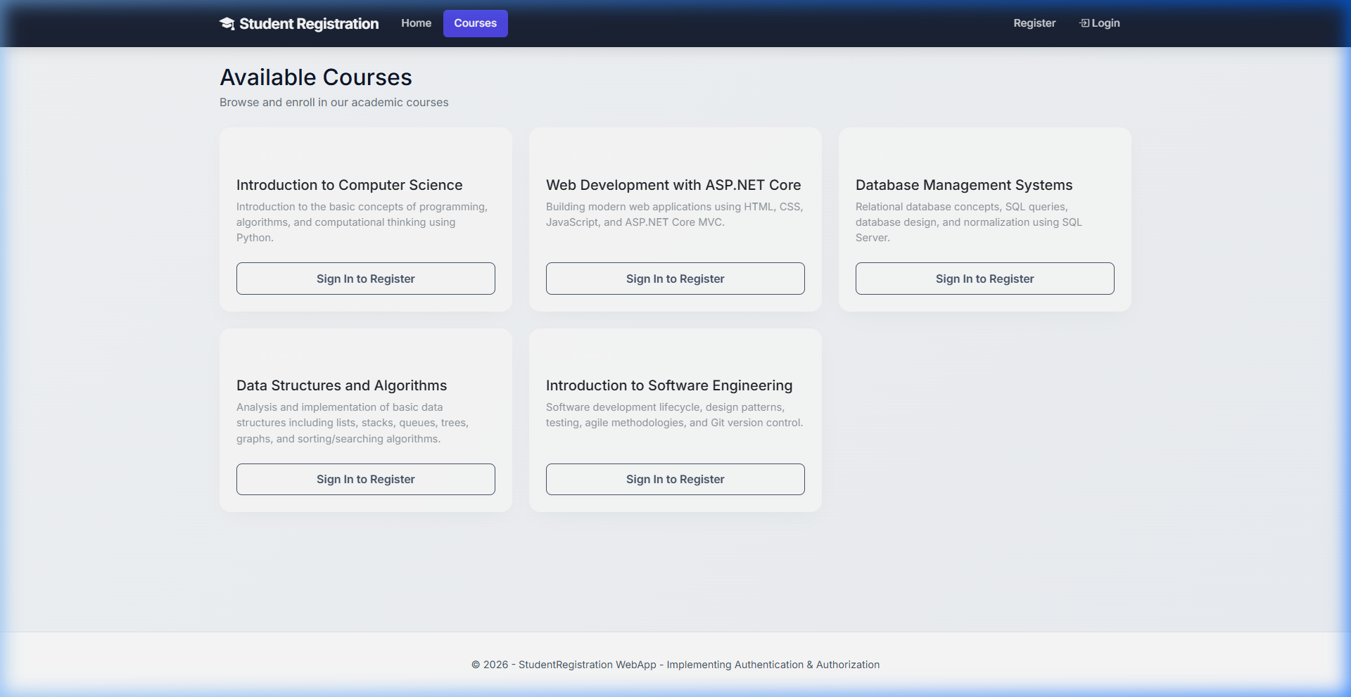

7. Student Profile Page
Displays student's personal details (First Name, Last Name, Email) and current enrolled course details.


8. Administrator — List of Students
Displays complete student roster table (/Students) showing registered student names, emails, and enrolled courses.


9. SQL Server Database — Identity and Application Tables
Demonstrates live SQL Server database persistence (StudentRegistrationDb) containing AspNetUsers, AspNetRoles, AspNetUserRoles, and Courses tables.
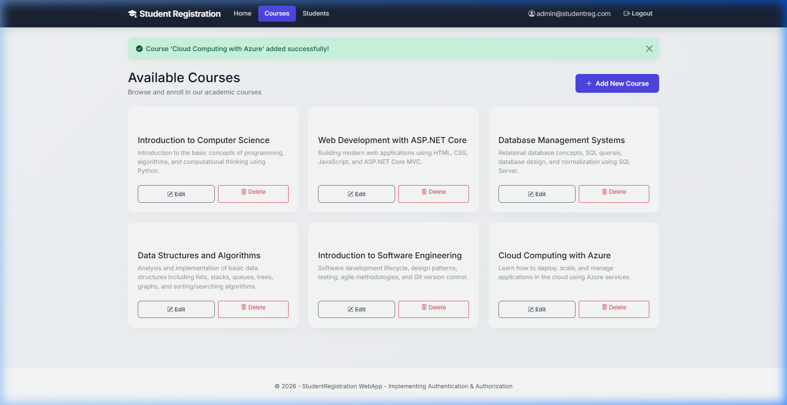

Part B: Complete Project Source Code

1. Project Configuration & AppSettings
📄 StudentRegistration.csproj
<Project Sdk="Microsoft.NET.Sdk.Web">
<PropertyGroup>
<TargetFramework>net10.0</TargetFramework>
<Nullable>enable</Nullable>
<ImplicitUsings>enable</ImplicitUsings>
</PropertyGroup>
<ItemGroup>
<PackageReference Include="Microsoft.AspNetCore.Identity.EntityFrameworkCore" Version="10.0.10" />
<PackageReference Include="Microsoft.EntityFrameworkCore.Design" Version="10.0.10">
<IncludeAssets>runtime; build; native; contentfiles; analyzers; buildtransitive</IncludeAssets>
<PrivateAssets>all</PrivateAssets>
</PackageReference>
<PackageReference Include="Microsoft.EntityFrameworkCore.SqlServer" Version="10.0.10" />
</ItemGroup>
</Project>
📄 appsettings.json
{
"Logging": {
"LogLevel": {
"Default": "Information",
"Microsoft.AspNetCore": "Warning"
}
},
"AllowedHosts": "*",
"ConnectionStrings": {
"DefaultConnection": "Server=localhost\\SQLEXPRESS;Database=StudentRegistrationDb;Trusted_Connection=True;MultipleActiveResultSets=true;TrustServerCertificate=True"
}
}
📄 Program.cs
using Microsoft.AspNetCore.Identity;
using Microsoft.EntityFrameworkCore;
using StudentRegistration.Data;
using StudentRegistration.Models;
var builder = WebApplication.CreateBuilder(args);
// Add services to the container.
builder.Services.AddControllersWithViews();
// 1. Configure EF Core DbContext with SQL Server Connection String
builder.Services.AddDbContext<ApplicationDbContext>(options =>
options.UseSqlServer(builder.Configuration.GetConnectionString("DefaultConnection")));
// 2. Configure ASP.NET Core Identity with ApplicationUser and IdentityRole
builder.Services.AddIdentity<ApplicationUser, IdentityRole>(options =>
{
// Password requirements (optional customization, standard Identity rules applied)
options.Password.RequireDigit = true;
options.Password.RequireLowercase = true;
options.Password.RequireUppercase = true;
options.Password.RequireNonAlphanumeric = true;
options.Password.RequiredLength = 6;
})
.AddEntityFrameworkStores<ApplicationDbContext>()
.AddDefaultTokenProviders();
// 3. Configure Cookies Redirect paths to match custom AccountController
builder.Services.ConfigureApplicationCookie(options =>
{
options.LoginPath = "/Account/Login";
options.AccessDeniedPath = "/Account/AccessDenied";
});
var app = builder.Build();
// 4. Run database creation and seeding at startup
using (var scope = app.Services.CreateScope())
{
var services = scope.ServiceProvider;
try
{
await DbInitializer.Initialize(services);
}
catch (Exception ex)
{
var logger = services.GetRequiredService<ILogger<Program>>();
logger.LogError(ex, "An error occurred while seeding the database.");
}
}
// Configure the HTTP request pipeline.
if (!app.Environment.IsDevelopment())
{
app.UseExceptionHandler("/Home/Error");
// The default HSTS value is 30 days. You may want to change this for production scenarios, see https://aka.ms/aspnetcore-hsts.
app.UseHsts();
}
app.UseHttpsRedirection();
app.UseRouting();
// 5. Enable Authentication & Authorization
app.UseAuthentication();
app.UseAuthorization();
app.MapStaticAssets();
app.MapControllerRoute(
name: "default",
pattern: "{controller=Home}/{action=Index}/{id?}")
.WithStaticAssets();
app.Run();

2. Data Models & ViewModels
📄 Models/Course.cs
using System.Collections.Generic;
using System.ComponentModel.DataAnnotations;
namespace StudentRegistration.Models
{
public class Course
{
public int Id { get; set; }
[Required]
[Display(Name = "Course Name")]
public string Name { get; set; } = string.Empty;
[Required]
public string Description { get; set; } = string.Empty;
[Required]
[Range(1, 10, ErrorMessage = "Credits must be between 1 and 10.")]
public int Credits { get; set; }
// Navigation property for students registered in this course
public virtual ICollection<ApplicationUser> Students { get; set; } = new List<ApplicationUser>();
}
}
📄 Models/ApplicationUser.cs
using Microsoft.AspNetCore.Identity;
using System.ComponentModel.DataAnnotations;
using System.ComponentModel.DataAnnotations.Schema;
namespace StudentRegistration.Models
{
public class ApplicationUser : IdentityUser
{
[Required]
[Display(Name = "First Name")]
public string FirstName { get; set; } = string.Empty;
[Required]
[Display(Name = "Last Name")]
public string LastName { get; set; } = string.Empty;
[Display(Name = "Registered Course")]
public int? RegisteredCourseId { get; set; }
[ForeignKey("RegisteredCourseId")]
public virtual Course? RegisteredCourse { get; set; }
}
}
📄 Models/ViewModels.cs
using System.ComponentModel.DataAnnotations;
namespace StudentRegistration.Models
{
public class LoginViewModel
{
[Required]
[EmailAddress]
public string Email { get; set; } = string.Empty;
[Required]
[DataType(DataType.Password)]
public string Password { get; set; } = string.Empty;
[Display(Name = "Remember me?")]
public bool RememberMe { get; set; }
}
public class RegisterViewModel
{
[Required]
[EmailAddress]
[Display(Name = "Email Address")]
public string Email { get; set; } = string.Empty;
[Required]
[StringLength(100, ErrorMessage = "The {0} must be at least {2} and at max {1} characters long.", MinimumLength = 6)]
[DataType(DataType.Password)]
public string Password { get; set; } = string.Empty;
[DataType(DataType.Password)]
[Display(Name = "Confirm password")]
[Compare("Password", ErrorMessage = "The password and confirmation password do not match.")]
public string ConfirmPassword { get; set; } = string.Empty;
[Required]
[Display(Name = "First Name")]
public string FirstName { get; set; } = string.Empty;
[Required]
[Display(Name = "Last Name")]
public string LastName { get; set; } = string.Empty;
}
public class EditProfileViewModel
{
[Required]
[Display(Name = "First Name")]
public string FirstName { get; set; } = string.Empty;
[Required]
[Display(Name = "Last Name")]
public string LastName { get; set; } = string.Empty;
}
}

3. Data Access Layer & Initializer
📄 Data/ApplicationDbContext.cs
using Microsoft.AspNetCore.Identity.EntityFrameworkCore;
using Microsoft.EntityFrameworkCore;
using StudentRegistration.Models;
namespace StudentRegistration.Data
{
public class ApplicationDbContext : IdentityDbContext<ApplicationUser>
{
public ApplicationDbContext(DbContextOptions<ApplicationDbContext> options)
: base(options)
{
}
public DbSet<Course> Courses { get; set; }
protected override void OnModelCreating(ModelBuilder builder)
{
base.OnModelCreating(builder);
// Configure relationship between Student (ApplicationUser) and Course
builder.Entity<ApplicationUser>()
.HasOne(u => u.RegisteredCourse)
.WithMany(c => c.Students)
.HasForeignKey(u => u.RegisteredCourseId)
.OnDelete(DeleteBehavior.SetNull); // If course is deleted, keep student but set registration to null
}
}
}
📄 Data/DbInitializer.cs
using Microsoft.AspNetCore.Identity;
using Microsoft.Extensions.DependencyInjection;
using StudentRegistration.Models;
using System;
using System.Linq;
using System.Threading.Tasks;
namespace StudentRegistration.Data
{
public static class DbInitializer
{
public static async Task Initialize(IServiceProvider serviceProvider)
{
using var context = serviceProvider.GetRequiredService<ApplicationDbContext>();
// Create database if not exists
context.Database.EnsureCreated();
var roleManager = serviceProvider.GetRequiredService<RoleManager<IdentityRole>>();
var userManager = serviceProvider.GetRequiredService<UserManager<ApplicationUser>>();
// 1. Seed Roles
string[] roleNames = { "Admin", "Student" };
foreach (var roleName in roleNames)
{
var roleExist = await roleManager.RoleExistsAsync(roleName);
if (!roleExist)
{
await roleManager.CreateAsync(new IdentityRole(roleName));
}
}
// 2. Seed Admin User
string adminEmail = "admin@studentreg.com";
var adminUser = await userManager.FindByEmailAsync(adminEmail);
if (adminUser == null)
{
var admin = new ApplicationUser
{
UserName = adminEmail,
Email = adminEmail,
FirstName = "System",
LastName = "Administrator",
EmailConfirmed = true
};
var createAdminResult = await userManager.CreateAsync(admin, "AdminPassword123!");
if (createAdminResult.Succeeded)
{
await userManager.AddToRoleAsync(admin, "Admin");
}
}
// 3. Seed Courses if none exist
if (!context.Courses.Any())
{
var courses = new Course[]
{
new Course
{
Name = "Introduction to Computer Science",
Credits = 4,
Description = "Introduction to the basic concepts of programming, algorithms, and computational thinking using Python."
},
new Course
{
Name = "Web Development with ASP.NET Core",
Credits = 3,
Description = "Building modern web applications using HTML, CSS, JavaScript, and ASP.NET Core MVC."
},
new Course
{
Name = "Database Management Systems",
Credits = 3,
Description = "Relational database concepts, SQL queries, database design, and normalization using SQL Server."
},
new Course
{
Name = "Data Structures and Algorithms",
Credits = 4,
Description = "Analysis and implementation of basic data structures including lists, stacks, queues, trees, graphs, and sorting/searching algorithms."
},
new Course
{
Name = "Introduction to Software Engineering",
Credits = 3,
Description = "Software development lifecycle, design patterns, testing, agile methodologies, and Git version control."
}
};
foreach (var course in courses)
{
context.Courses.Add(course);
}
context.SaveChanges();
}
}
}
}

4. Controllers (Logic & Security)
📄 Controllers/AccountController.cs
using Microsoft.AspNetCore.Identity;
using Microsoft.AspNetCore.Mvc;
using StudentRegistration.Models;
using System.Threading.Tasks;
namespace StudentRegistration.Controllers
{
public class AccountController : Controller
{
private readonly UserManager<ApplicationUser> _userManager;
private readonly SignInManager<ApplicationUser> _signInManager;
public AccountController(UserManager<ApplicationUser> userManager, SignInManager<ApplicationUser> signInManager)
{
_userManager = userManager;
_signInManager = signInManager;
}
[HttpGet]
public IActionResult Register()
{
if (User.Identity?.IsAuthenticated == true)
{
return RedirectToAction("Index", "Home");
}
return View();
}
[HttpPost]
[ValidateAntiForgeryToken]
public async Task<IActionResult> Register(RegisterViewModel model)
{
if (ModelState.IsValid)
{
var user = new ApplicationUser
{
UserName = model.Email,
Email = model.Email,
FirstName = model.FirstName,
LastName = model.LastName
};
var result = await _userManager.CreateAsync(user, model.Password);
if (result.Succeeded)
{
// Every new user automatically assigned the Student role
await _userManager.AddToRoleAsync(user, "Student");
// Sign in the user
await _signInManager.SignInAsync(user, isPersistent: false);
TempData["SuccessMessage"] = "Registration successful! Welcome to Student Registration.";
return RedirectToAction("Index", "Profile");
}
foreach (var error in result.Errors)
{
ModelState.AddModelError(string.Empty, error.Description);
}
}
return View(model);
}
[HttpGet]
public IActionResult Login(string? returnUrl = null)
{
if (User.Identity?.IsAuthenticated == true)
{
return RedirectToAction("Index", "Home");
}
ViewData["ReturnUrl"] = returnUrl;
return View();
}
[HttpPost]
[ValidateAntiForgeryToken]
public async Task<IActionResult> Login(LoginViewModel model, string? returnUrl = null)
{
ViewData["ReturnUrl"] = returnUrl;
if (ModelState.IsValid)
{
var result = await _signInManager.PasswordSignInAsync(model.Email, model.Password, model.RememberMe, lockoutOnFailure: false);
if (result.Succeeded)
{
var user = await _userManager.FindByEmailAsync(model.Email);
if (user != null)
{
TempData["SuccessMessage"] = $"Welcome back, {user.FirstName}!";
if (!string.IsNullOrEmpty(returnUrl) && Url.IsLocalUrl(returnUrl))
{
return Redirect(returnUrl);
}
// Role-based redirection
var roles = await _userManager.GetRolesAsync(user);
if (roles.Contains("Admin"))
{
return RedirectToAction("Index", "Students");
}
else if (roles.Contains("Student"))
{
return RedirectToAction("Index", "Profile");
}
}
return RedirectToAction("Index", "Home");
}
ModelState.AddModelError(string.Empty, "Invalid login attempt. Please check your email and password.");
}
return View(model);
}
[HttpPost]
[ValidateAntiForgeryToken]
public async Task<IActionResult> Logout()
{
await _signInManager.SignOutAsync();
TempData["SuccessMessage"] = "You have been logged out successfully.";
return RedirectToAction("Index", "Home");
}
[HttpGet]
public IActionResult AccessDenied()
{
return View();
}
}
}
📄 Controllers/CoursesController.cs
using Microsoft.AspNetCore.Authorization;
using Microsoft.AspNetCore.Identity;
using Microsoft.AspNetCore.Mvc;
using Microsoft.EntityFrameworkCore;
using StudentRegistration.Data;
using StudentRegistration.Models;
using System.Linq;
using System.Threading.Tasks;
namespace StudentRegistration.Controllers
{
public class CoursesController : Controller
{
private readonly ApplicationDbContext _context;
private readonly UserManager<ApplicationUser> _userManager;
public CoursesController(ApplicationDbContext context, UserManager<ApplicationUser> userManager)
{
_context = context;
_userManager = userManager;
}
// GET: Courses
[AllowAnonymous]
public async Task<IActionResult> Index()
{
var courses = await _context.Courses.ToListAsync();
// Check if current user is a student and if they are already registered for a course
if (User.Identity?.IsAuthenticated == true)
{
var user = await _userManager.GetUserAsync(User);
if (user != null)
{
ViewBag.HasRegisteredCourse = user.RegisteredCourseId.HasValue;
ViewBag.RegisteredCourseId = user.RegisteredCourseId;
ViewBag.IsStudent = User.IsInRole("Student");
}
}
return View(courses);
}
// GET: Courses/Create
[Authorize(Roles = "Admin")]
public IActionResult Create()
{
return View();
}
// POST: Courses/Create
[HttpPost]
[ValidateAntiForgeryToken]
[Authorize(Roles = "Admin")]
public async Task<IActionResult> Create([Bind("Id,Name,Description,Credits")] Course course)
{
if (ModelState.IsValid)
{
_context.Add(course);
await _context.SaveChangesAsync();
TempData["SuccessMessage"] = $"Course '{course.Name}' added successfully!";
return RedirectToAction(nameof(Index));
}
return View(course);
}
// GET: Courses/Edit/5
[Authorize(Roles = "Admin")]
public async Task<IActionResult> Edit(int? id)
{
if (id == null)
{
return NotFound();
}
var course = await _context.Courses.FindAsync(id);
if (course == null)
{
return NotFound();
}
return View(course);
}
// POST: Courses/Edit/5
[HttpPost]
[ValidateAntiForgeryToken]
[Authorize(Roles = "Admin")]
public async Task<IActionResult> Edit(int id, [Bind("Id,Name,Description,Credits")] Course course)
{
if (id != course.Id)
{
return NotFound();
}
if (ModelState.IsValid)
{
try
{
_context.Update(course);
await _context.SaveChangesAsync();
TempData["SuccessMessage"] = $"Course '{course.Name}' updated successfully!";
}
catch (DbUpdateConcurrencyException)
{
if (!CourseExists(course.Id))
{
return NotFound();
}
else
{
throw;
}
}
return RedirectToAction(nameof(Index));
}
return View(course);
}
// GET: Courses/Delete/5
[Authorize(Roles = "Admin")]
public async Task<IActionResult> Delete(int? id)
{
if (id == null)
{
return NotFound();
}
var course = await _context.Courses
.FirstOrDefaultAsync(m => m.Id == id);
if (course == null)
{
return NotFound();
}
return View(course);
}
// POST: Courses/Delete/5
[HttpPost, ActionName("Delete")]
[ValidateAntiForgeryToken]
[Authorize(Roles = "Admin")]
public async Task<IActionResult> DeleteConfirmed(int id)
{
var course = await _context.Courses.FindAsync(id);
if (course != null)
{
string courseName = course.Name;
_context.Courses.Remove(course);
await _context.SaveChangesAsync();
TempData["SuccessMessage"] = $"Course '{courseName}' deleted successfully!";
}
return RedirectToAction(nameof(Index));
}
private bool CourseExists(int id)
{
return _context.Courses.Any(e => e.Id == id);
}
}
}
📄 Controllers/ProfileController.cs
using Microsoft.AspNetCore.Authorization;
using Microsoft.AspNetCore.Identity;
using Microsoft.AspNetCore.Mvc;
using Microsoft.EntityFrameworkCore;
using StudentRegistration.Data;
using StudentRegistration.Models;
using System.Threading.Tasks;
namespace StudentRegistration.Controllers
{
[Authorize(Roles = "Student")]
public class ProfileController : Controller
{
private readonly UserManager<ApplicationUser> _userManager;
private readonly ApplicationDbContext _context;
public ProfileController(UserManager<ApplicationUser> userManager, ApplicationDbContext context)
{
_userManager = userManager;
_context = context;
}
// GET: Profile
public async Task<IActionResult> Index()
{
var user = await _userManager.GetUserAsync(User);
if (user == null)
{
return Challenge();
}
// Load the registered course details
var userWithCourse = await _context.Users
.Include(u => u.RegisteredCourse)
.FirstOrDefaultAsync(u => u.Id == user.Id);
return View(userWithCourse);
}
// GET: Profile/Edit
public async Task<IActionResult> Edit()
{
var user = await _userManager.GetUserAsync(User);
if (user == null)
{
return Challenge();
}
var model = new EditProfileViewModel
{
FirstName = user.FirstName,
LastName = user.LastName
};
return View(model);
}
// POST: Profile/Edit
[HttpPost]
[ValidateAntiForgeryToken]
public async Task<IActionResult> Edit(EditProfileViewModel model)
{
if (ModelState.IsValid)
{
var user = await _userManager.GetUserAsync(User);
if (user == null)
{
return Challenge();
}
user.FirstName = model.FirstName;
user.LastName = model.LastName;
var result = await _userManager.UpdateAsync(user);
if (result.Succeeded)
{
TempData["SuccessMessage"] = "Profile details updated successfully!";
return RedirectToAction(nameof(Index));
}
foreach (var error in result.Errors)
{
ModelState.AddModelError(string.Empty, error.Description);
}
}
return View(model);
}
// POST: Profile/RegisterCourse
[HttpPost]
[ValidateAntiForgeryToken]
public async Task<IActionResult> RegisterCourse(int courseId)
{
var user = await _userManager.GetUserAsync(User);
if (user == null)
{
return Challenge();
}
// Reload user with current DB state to ensure concurrency check
var dbUser = await _context.Users.FindAsync(user.Id);
if (dbUser == null)
{
return NotFound();
}
// Rule: Register for only one course
if (dbUser.RegisteredCourseId.HasValue)
{
TempData["ErrorMessage"] = "You are already registered for a course. You can only register for one course.";
return RedirectToAction("Index", "Courses");
}
var course = await _context.Courses.FindAsync(courseId);
if (course == null)
{
TempData["ErrorMessage"] = "The selected course does not exist.";
return RedirectToAction("Index", "Courses");
}
dbUser.RegisteredCourseId = courseId;
await _context.SaveChangesAsync();
TempData["SuccessMessage"] = $"Successfully registered for the course: '{course.Name}'!";
return RedirectToAction(nameof(Index));
}
}
}
📄 Controllers/StudentsController.cs
using Microsoft.AspNetCore.Authorization;
using Microsoft.AspNetCore.Identity;
using Microsoft.AspNetCore.Mvc;
using Microsoft.EntityFrameworkCore;
using StudentRegistration.Data;
using StudentRegistration.Models;
using System.Collections.Generic;
using System.Linq;
using System.Threading.Tasks;
namespace StudentRegistration.Controllers
{
[Authorize(Roles = "Admin")]
public class StudentsController : Controller
{
private readonly UserManager<ApplicationUser> _userManager;
private readonly ApplicationDbContext _context;
public StudentsController(UserManager<ApplicationUser> userManager, ApplicationDbContext context)
{
_userManager = userManager;
_context = context;
}
// GET: Students
public async Task<IActionResult> Index()
{
// Get all users in the Student role
var students = await _userManager.GetUsersInRoleAsync("Student");
// To ensure we get the course details, let's load them from the database context
var studentIds = students.Select(s => s.Id).ToList();
var studentsWithCourses = await _context.Users
.Include(u => u.RegisteredCourse)
.Where(u => studentIds.Contains(u.Id))
.ToListAsync();
return View(studentsWithCourses);
}
}
}
📄 Controllers/HomeController.cs
using System.Diagnostics;
using Microsoft.AspNetCore.Mvc;
using StudentRegistration.Models;
namespace StudentRegistration.Controllers;
public class HomeController : Controller
{
public IActionResult Index()
{
return View();
}
public IActionResult Privacy()
{
return View();
}
[ResponseCache(Duration = 0, Location = ResponseCacheLocation.None, NoStore = true)]
public IActionResult Error()
{
return View(new ErrorViewModel { RequestId = Activity.Current?.Id ?? HttpContext.TraceIdentifier });
}
}

5. Views — Shared Layout & Master Templates
📄 Views/Shared/_Layout.cshtml
@inject Microsoft.AspNetCore.Identity.UserManager<StudentRegistration.Models.ApplicationUser> UserManager
<!DOCTYPE html>
<html lang="en">
<head>
<meta charset="utf-8" />
<meta name="viewport" content="width=device-width, initial-scale=1.0" />
<title>@ViewData["Title"] - Student Registration</title>
<link rel="stylesheet" href="~/lib/bootstrap/dist/css/bootstrap.min.css" />
<link rel="stylesheet" href="~/css/site.css" asp-append-version="true" />
<link rel="stylesheet" href="~/StudentRegistration.styles.css" asp-append-version="true" />
<link rel="stylesheet" href="https://cdn.jsdelivr.net/npm/bootstrap-icons@1.11.3/font/bootstrap-icons.min.css">
</head>
<body>
<header>
<nav class="navbar navbar-expand-sm navbar-toggleable-sm navbar-dark navbar-custom mb-4">
<div class="container">
<a class="navbar-brand" asp-area="" asp-controller="Home" asp-action="Index">
<i class="bi bi-mortarboard-fill me-2"></i>Student Registration
</a>
<button class="navbar-toggler" type="button" data-bs-toggle="collapse" data-bs-target=".navbar-collapse" aria-controls="navbarSupportedContent"
aria-expanded="false" aria-label="Toggle navigation">
<span class="navbar-toggler-icon"></span>
</button>
<div class="navbar-collapse collapse d-sm-inline-flex justify-content-between">
<ul class="navbar-nav flex-grow-1">
<li class="nav-item">
<a class="nav-link @(ViewContext.RouteData.Values["controller"]?.ToString() == "Home" && ViewContext.RouteData.Values["action"]?.ToString() == "Index" ? "active-custom" : "")"
asp-area="" asp-controller="Home" asp-action="Index">Home</a>
</li>
<li class="nav-item">
<a class="nav-link @(ViewContext.RouteData.Values["controller"]?.ToString() == "Courses" && ViewContext.RouteData.Values["action"]?.ToString() == "Index" ? "active-custom" : "")"
asp-area="" asp-controller="Courses" asp-action="Index">Courses</a>
</li>
@if (User.Identity?.IsAuthenticated == true)
{
var user = await UserManager.GetUserAsync(User);
var isAdmin = User.IsInRole("Admin");
var isStudent = User.IsInRole("Student");
if (isAdmin)
{
<li class="nav-item">
<a class="nav-link @(ViewContext.RouteData.Values["controller"]?.ToString() == "Students" ? "active-custom" : "")"
asp-area="" asp-controller="Students" asp-action="Index">Students</a>
</li>
}
else if (isStudent)
{
var hasRegistered = user?.RegisteredCourseId.HasValue == true;
if (!hasRegistered)
{
<li class="nav-item">
<a class="nav-link" asp-controller="Courses" asp-action="Index">
<i class="bi bi-plus-circle-fill me-1"></i>Register for Course
</a>
</li>
}
<li class="nav-item">
<a class="nav-link @(ViewContext.RouteData.Values["controller"]?.ToString() == "Profile" && ViewContext.RouteData.Values["action"]?.ToString() == "Index" ? "active-custom" : "")"
asp-area="" asp-controller="Profile" asp-action="Index">My Profile</a>
</li>
}
}
</ul>
<ul class="navbar-nav">
@if (User.Identity?.IsAuthenticated == true)
{
<li class="nav-item d-flex align-items-center me-3">
<span class="text-light text-opacity-75">
<i class="bi bi-person-circle me-1"></i>@User.Identity.Name
</span>
</li>
<li class="nav-item">
<form asp-controller="Account" asp-action="Logout" method="post" id="logoutForm" class="d-inline">
@Html.AntiForgeryToken()
<button type="submit" class="btn nav-link border-0 bg-transparent">
<i class="bi bi-box-arrow-right me-1"></i>Logout
</button>
</form>
</li>
}
else
{
<li class="nav-item">
<a class="nav-link @(ViewContext.RouteData.Values["controller"]?.ToString() == "Account" && ViewContext.RouteData.Values["action"]?.ToString() == "Register" ? "active-custom" : "")"
asp-controller="Account" asp-action="Register">Register</a>
</li>
<li class="nav-item">
<a class="nav-link @(ViewContext.RouteData.Values["controller"]?.ToString() == "Account" && ViewContext.RouteData.Values["action"]?.ToString() == "Login" ? "active-custom" : "")"
asp-controller="Account" asp-action="Login">
<i class="bi bi-box-arrow-in-right me-1"></i>Login
</a>
</li>
}
</ul>
</div>
</div>
</nav>
</header>
<div class="container">
<main role="main" class="pb-3">
@if (TempData["SuccessMessage"] != null)
{
<div class="alert alert-success-custom alert-custom alert-dismissible fade show" role="alert">
<i class="bi bi-check-circle-fill me-2"></i>@TempData["SuccessMessage"]
<button type="button" class="btn-close" data-bs-dismiss="alert" aria-label="Close"></button>
</div>
}
@if (TempData["ErrorMessage"] != null)
{
<div class="alert alert-danger-custom alert-custom alert-dismissible fade show" role="alert">
<i class="bi bi-exclamation-triangle-fill me-2"></i>@TempData["ErrorMessage"]
<button type="button" class="btn-close" data-bs-dismiss="alert" aria-label="Close"></button>
</div>
}
@RenderBody()
</main>
</div>
<footer class="footer mt-auto py-3">
<div class="container text-center">
&copy; 2026 - StudentRegistration WebApp - Implementing Authentication & Authorization
</div>
</footer>
<script src="~/lib/jquery/dist/jquery.min.js"></script>
<script src="~/lib/bootstrap/dist/js/bootstrap.bundle.min.js"></script>
<script src="~/js/site.js" asp-append-version="true"></script>
@await RenderSectionAsync("Scripts", required: false)
</body>
</html>

6. Views — Home & Account Authentication
📄 Views/Home/Index.cshtml
@{
ViewData["Title"] = "Home Page";
}
<div class="hero-section glass-card p-5">
<div class="row align-items-center">
<div class="col-lg-8 mx-auto text-center">
<h1 class="hero-title">Welcome to Student Registration Portal</h1>
<p class="hero-subtitle">
A secure, state-of-the-art platform for managing course enrollments, student records, and role-based operations using ASP.NET Core Identity.
</p>
<div class="d-flex justify-content-center gap-3">
@if (User.Identity?.IsAuthenticated == true)
{
if (User.IsInRole("Admin"))
{
<a asp-controller="Students" asp-action="Index" class="btn btn-primary-custom px-4 py-2">
<i class="bi bi-people-fill me-2"></i>Manage Students
</a>
<a asp-controller="Courses" asp-action="Index" class="btn btn-secondary-custom px-4 py-2">
<i class="bi bi-book-fill me-2"></i>Manage Courses
</a>
}
else if (User.IsInRole("Student"))
{
<a asp-controller="Profile" asp-action="Index" class="btn btn-primary-custom px-4 py-2">
<i class="bi bi-person-badge-fill me-2"></i>Go to Profile
</a>
<a asp-controller="Courses" asp-action="Index" class="btn btn-secondary-custom px-4 py-2">
<i class="bi bi-book-half me-2"></i>Browse Courses
</a>
}
}
else
{
<a asp-controller="Account" asp-action="Login" class="btn btn-primary-custom px-4 py-2">
<i class="bi bi-box-arrow-in-right me-2"></i>Get Started
</a>
<a asp-controller="Account" asp-action="Register" class="btn btn-secondary-custom px-4 py-2">
<i class="bi bi-person-plus-fill me-2"></i>Create Account
</a>
}
</div>
</div>
</div>
</div>
<div class="row mt-4 g-4">
<div class="col-md-4">
<div class="card glass-card h-100 p-4 border-0">
<div class="card-body text-center d-flex flex-column align-items-center">
<div class="bg-primary bg-opacity-10 p-3 rounded-circle text-primary mb-3">
<i class="bi bi-shield-lock-fill fs-2"></i>
</div>
<h3 class="card-title h5 font-weight-bold">Authentication</h3>
<p class="card-text text-secondary text-opacity-75">
Secure ASP.NET Core Identity engine managing password hashing, cookie-based sessions, and secure login workflows.
</p>
</div>
</div>
</div>
<div class="col-md-4">
<div class="card glass-card h-100 p-4 border-0">
<div class="card-body text-center d-flex flex-column align-items-center">
<div class="bg-cyan bg-opacity-10 p-3 rounded-circle text-info mb-3">
<i class="bi bi-person-vcard-fill fs-2"></i>
</div>
<h3 class="card-title h5 font-weight-bold">Authorization</h3>
<p class="card-text text-secondary text-opacity-75">
Role-Based Access Control (RBAC) ensuring only validated Students register for courses, and only Admins edit catalogs.
</p>
</div>
</div>
</div>
<div class="col-md-4">
<div class="card glass-card h-100 p-4 border-0">
<div class="card-body text-center d-flex flex-column align-items-center">
<div class="bg-indigo bg-opacity-10 p-3 rounded-circle text-indigo mb-3">
<i class="bi bi-sliders fs-2"></i>
</div>
<h3 class="card-title h5 font-weight-bold">Dynamic Navigation</h3>
<p class="card-text text-secondary text-opacity-75">
Interactive menus that automatically adjust depending on role and status, hiding student registration after enrollment.
</p>
</div>
</div>
</div>
</div>
📄 Views/Account/Login.cshtml
@model StudentRegistration.Models.LoginViewModel
@{
ViewData["Title"] = "Login";
}
<div class="row justify-content-center">
<div class="col-md-6 col-lg-5">
<div class="card glass-card border-0 p-4">
<div class="card-body">
<div class="text-center mb-4">
<div class="bg-primary bg-opacity-10 p-3 rounded-circle text-primary d-inline-flex mb-3">
<i class="bi bi-box-arrow-in-right fs-2"></i>
</div>
<h2 class="font-weight-bold h4">Welcome Back</h2>
<p class="text-secondary text-opacity-75">Sign in to manage your registration portal</p>
</div>
<form asp-action="Login" asp-route-returnUrl="@ViewData["ReturnUrl"]" method="post">
@Html.AntiForgeryToken()
<div asp-validation-summary="ModelOnly" class="text-danger mb-3"></div>
<div class="form-floating mb-3">
<input asp-for="Email" class="form-control" placeholder="name@example.com" required autocomplete="username" />
<label asp-for="Email">Email Address</label>
<span asp-validation-for="Email" class="text-danger"></span>
</div>
<div class="form-floating mb-3">
<input asp-for="Password" class="form-control" placeholder="Password" required autocomplete="current-password" />
<label asp-for="Password">Password</label>
<span asp-validation-for="Password" class="text-danger"></span>
</div>
<div class="form-check mb-4">
<input class="form-check-input" asp-for="RememberMe" />
<label class="form-check-label" asp-for="RememberMe">
@Html.DisplayNameFor(m => m.RememberMe)
</label>
</div>
<button type="submit" class="btn btn-primary-custom w-100 py-3 mb-3">
Sign In
</button>
<div class="text-center">
<p class="mb-0 text-secondary">
Don't have an account?
<a asp-action="Register" class="text-primary font-weight-bold text-decoration-none">Register here</a>
</p>
</div>
</form>
</div>
</div>
</div>
</div>
@section Scripts {
@await Html.PartialAsync("_ValidationScriptsPartial")
}
📄 Views/Account/Register.cshtml
@model StudentRegistration.Models.RegisterViewModel
@{
ViewData["Title"] = "Register";
}
<div class="row justify-content-center">
<div class="col-md-7 col-lg-6">
<div class="card glass-card border-0 p-4">
<div class="card-body">
<div class="text-center mb-4">
<div class="bg-indigo bg-opacity-10 p-3 rounded-circle text-indigo d-inline-flex mb-3">
<i class="bi bi-person-plus-fill fs-2"></i>
</div>
<h2 class="font-weight-bold h4">Create an Account</h2>
<p class="text-secondary text-opacity-75">Join as a student to register for courses</p>
</div>
<form asp-action="Register" method="post">
@Html.AntiForgeryToken()
<div asp-validation-summary="ModelOnly" class="text-danger mb-3"></div>
<div class="row">
<div class="col-md-6 mb-3">
<div class="form-floating">
<input asp-for="FirstName" class="form-control" placeholder="First Name" required />
<label asp-for="FirstName">First Name</label>
<span asp-validation-for="FirstName" class="text-danger"></span>
</div>
</div>
<div class="col-md-6 mb-3">
<div class="form-floating">
<input asp-for="LastName" class="form-control" placeholder="Last Name" required />
<label asp-for="LastName">Last Name</label>
<span asp-validation-for="LastName" class="text-danger"></span>
</div>
</div>
</div>
<div class="form-floating mb-3">
<input asp-for="Email" class="form-control" placeholder="name@example.com" required autocomplete="username" />
<label asp-for="Email">Email Address</label>
<span asp-validation-for="Email" class="text-danger"></span>
</div>
<div class="form-floating mb-3">
<input asp-for="Password" class="form-control" placeholder="Password" required autocomplete="new-password" />
<label asp-for="Password">Password</label>
<span asp-validation-for="Password" class="text-danger"></span>
</div>
<div class="form-floating mb-4">
<input asp-for="ConfirmPassword" class="form-control" placeholder="Confirm Password" required autocomplete="new-password" />
<label asp-for="ConfirmPassword">Confirm Password</label>
<span asp-validation-for="ConfirmPassword" class="text-danger"></span>
</div>
<button type="submit" class="btn btn-primary-custom w-100 py-3 mb-3">
Create Account
</button>
<div class="text-center">
<p class="mb-0 text-secondary">
Already have an account?
<a asp-action="Login" class="text-primary font-weight-bold text-decoration-none">Sign in here</a>
</p>
</div>
</form>
</div>
</div>
</div>
</div>
@section Scripts {
@await Html.PartialAsync("_ValidationScriptsPartial")
}
📄 Views/Account/AccessDenied.cshtml
@{
ViewData["Title"] = "Access Denied";
}
<div class="row justify-content-center py-5">
<div class="col-md-6 text-center">
<div class="card glass-card border-0 p-5">
<div class="card-body">
<div class="text-danger mb-4">
<i class="bi bi-shield-slash fs-1 d-block mb-3" style="font-size: 5rem !important;"></i>
</div>
<h1 class="h2 font-weight-bold mb-3">Access Denied</h1>
<p class="text-secondary mb-4">
You do not have permission to view this resource. This area is restricted based on system security permissions.
</p>
<div class="d-flex justify-content-center gap-3">
<a asp-controller="Home" asp-action="Index" class="btn btn-primary-custom">
<i class="bi bi-house-door-fill me-2"></i>Return Home
</a>
@if (User.Identity?.IsAuthenticated == false)
{
<a asp-controller="Account" asp-action="Login" class="btn btn-secondary-custom">
<i class="bi bi-box-arrow-in-right me-2"></i>Sign In
</a>
}
</div>
</div>
</div>
</div>
</div>

7. Views — Courses, Student Profile & Admin Roster
📄 Views/Courses/Index.cshtml
@model IEnumerable<StudentRegistration.Models.Course>
@{
ViewData["Title"] = "Course Directory";
var hasRegistered = ViewBag.HasRegisteredCourse == true;
var registeredId = ViewBag.RegisteredCourseId as int?;
var isStudent = ViewBag.IsStudent == true;
}
<div class="d-flex justify-content-between align-items-center mb-4">
<div>
<h1 class="h2 font-weight-bold mb-1">Available Courses</h1>
<p class="text-secondary mb-0">Browse and enroll in our academic courses</p>
</div>
@if (User.IsInRole("Admin"))
{
<a asp-action="Create" class="btn btn-primary-custom">
<i class="bi bi-plus-lg me-2"></i>Add New Course
</a>
}
</div>
@if (!Model.Any())
{
<div class="card glass-card p-5 text-center border-0">
<div class="text-secondary mb-3">
<i class="bi bi-journal-x" style="font-size: 3rem;"></i>
</div>
<h5>No Courses Available</h5>
<p class="text-secondary text-opacity-75">There are currently no courses in the registry.</p>
</div>
}
else
{
<div class="row g-4">
@foreach (var item in Model)
{
<div class="col-md-6 col-lg-4">
<div class="card glass-card h-100 border-0 d-flex flex-column justify-content-between">
<div class="card-body p-4">
<div class="d-flex justify-content-between align-items-start mb-3">
<span class="badge bg-indigo bg-opacity-10 text-indigo px-3 py-2 rounded-pill font-weight-bold" style="font-size: 0.85rem;">
<i class="bi bi-award me-1"></i>@item.Credits Credits
</span>
@if (isStudent && registeredId == item.Id)
{
<span class="badge bg-success bg-opacity-10 text-success px-3 py-2 rounded-pill font-weight-bold" style="font-size: 0.85rem;">
<i class="bi bi-check-circle-fill me-1"></i>Registered
</span>
}
</div>
<h3 class="h5 card-title font-weight-bold mb-2">@item.Name</h3>
<p class="card-text text-secondary text-opacity-75" style="font-size: 0.92rem; line-height: 1.5;">
@item.Description
</p>
</div>
<div class="card-footer bg-transparent border-0 px-4 pb-4 pt-0">
@if (User.IsInRole("Admin"))
{
<div class="d-flex gap-2">
<a asp-action="Edit" asp-route-id="@item.Id" class="btn btn-sm btn-secondary-custom flex-grow-1">
<i class="bi bi-pencil-square me-1"></i>Edit
</a>
<a asp-action="Delete" asp-route-id="@item.Id" class="btn btn-sm btn-outline-danger flex-grow-1">
<i class="bi bi-trash3 me-1"></i>Delete
</a>
</div>
}
else if (isStudent)
{
if (!hasRegistered)
{
<form asp-controller="Profile" asp-action="RegisterCourse" method="post">
@Html.AntiForgeryToken()
<input type="hidden" name="courseId" value="@item.Id" />
<button type="submit" class="btn btn-primary-custom w-100">
<i class="bi bi-plus-circle me-1"></i>Register for Course
</button>
</form>
}
else if (registeredId != item.Id)
{
<button class="btn btn-secondary-custom w-100" disabled>
Only One Registration Allowed
</button>
}
}
else if (User.Identity?.IsAuthenticated != true)
{
<a asp-controller="Account" asp-action="Login" class="btn btn-secondary-custom w-100">
Sign In to Register
</a>
}
</div>
</div>
</div>
}
</div>
}
📄 Views/Courses/Create.cshtml
@model StudentRegistration.Models.Course
@{
ViewData["Title"] = "Add New Course";
}
<div class="row justify-content-center">
<div class="col-md-8 col-lg-6">
<div class="card glass-card border-0 p-4">
<div class="card-body">
<div class="d-flex align-items-center mb-4">
<a asp-action="Index" class="btn btn-sm btn-secondary-custom me-3 py-2 px-3">
<i class="bi bi-arrow-left"></i>
</a>
<div>
<h2 class="font-weight-bold h4 mb-0">Add New Course</h2>
<p class="text-secondary mb-0 text-opacity-75" style="font-size: 0.9rem;">Create a course for students to register</p>
</div>
</div>
<form asp-action="Create" method="post">
@Html.AntiForgeryToken()
<div asp-validation-summary="ModelOnly" class="text-danger mb-3"></div>
<div class="form-floating mb-3">
<input asp-for="Name" class="form-control" placeholder="Course Name" required />
<label asp-for="Name">Course Name</label>
<span asp-validation-for="Name" class="text-danger"></span>
</div>
<div class="form-floating mb-3">
<input asp-for="Credits" class="form-control" placeholder="Credits" type="number" min="1" max="10" required />
<label asp-for="Credits">Credits</label>
<span asp-validation-for="Credits" class="text-danger"></span>
</div>
<div class="form-floating mb-4">
<textarea asp-for="Description" class="form-control" placeholder="Description" style="height: 120px;" required></textarea>
<label asp-for="Description">Course Description</label>
<span asp-validation-for="Description" class="text-danger"></span>
</div>
<button type="submit" class="btn btn-primary-custom w-100 py-3">
Save Course
</button>
</form>
</div>
</div>
</div>
</div>
@section Scripts {
@await Html.PartialAsync("_ValidationScriptsPartial")
}
📄 Views/Courses/Edit.cshtml
@model StudentRegistration.Models.Course
@{
ViewData["Title"] = "Edit Course";
}
<div class="row justify-content-center">
<div class="col-md-8 col-lg-6">
<div class="card glass-card border-0 p-4">
<div class="card-body">
<div class="d-flex align-items-center mb-4">
<a asp-action="Index" class="btn btn-sm btn-secondary-custom me-3 py-2 px-3">
<i class="bi bi-arrow-left"></i>
</a>
<div>
<h2 class="font-weight-bold h4 mb-0">Edit Course</h2>
<p class="text-secondary mb-0 text-opacity-75" style="font-size: 0.9rem;">Modify course catalog details</p>
</div>
</div>
<form asp-action="Edit" method="post">
@Html.AntiForgeryToken()
<div asp-validation-summary="ModelOnly" class="text-danger mb-3"></div>
<input type="hidden" asp-for="Id" />
<div class="form-floating mb-3">
<input asp-for="Name" class="form-control" placeholder="Course Name" required />
<label asp-for="Name">Course Name</label>
<span asp-validation-for="Name" class="text-danger"></span>
</div>
<div class="form-floating mb-3">
<input asp-for="Credits" class="form-control" placeholder="Credits" type="number" min="1" max="10" required />
<label asp-for="Credits">Credits</label>
<span asp-validation-for="Credits" class="text-danger"></span>
</div>
<div class="form-floating mb-4">
<textarea asp-for="Description" class="form-control" placeholder="Description" style="height: 120px;" required></textarea>
<label asp-for="Description">Course Description</label>
<span asp-validation-for="Description" class="text-danger"></span>
</div>
<button type="submit" class="btn btn-primary-custom w-100 py-3">
Update Course
</button>
</form>
</div>
</div>
</div>
</div>
@section Scripts {
@await Html.PartialAsync("_ValidationScriptsPartial")
}
📄 Views/Courses/Delete.cshtml
@model StudentRegistration.Models.Course
@{
ViewData["Title"] = "Delete Course";
}
<div class="row justify-content-center">
<div class="col-md-8 col-lg-6">
<div class="card glass-card border-0 p-4">
<div class="card-body">
<div class="text-center mb-4">
<div class="text-danger mb-3">
<i class="bi bi-exclamation-triangle-fill fs-1"></i>
</div>
<h2 class="font-weight-bold h4">Are you sure?</h2>
<p class="text-secondary text-opacity-75">You are about to delete this course from the system. This action cannot be undone.</p>
</div>
<div class="p-3 bg-light rounded-3 mb-4 border">
<h4 class="h5 font-weight-bold text-dark mb-1">@Model.Name</h4>
<p class="text-secondary mb-2 small"><i class="bi bi-award me-1"></i>@Model.Credits Credits</p>
<p class="text-secondary mb-0 text-opacity-75" style="font-size: 0.9rem;">@Model.Description</p>
</div>
<form asp-action="Delete" method="post">
@Html.AntiForgeryToken()
<input type="hidden" asp-for="Id" />
<div class="d-flex gap-3">
<a asp-action="Index" class="btn btn-secondary-custom flex-grow-1">
Cancel
</a>
<button type="submit" class="btn btn-danger flex-grow-1 font-weight-bold py-2">
Yes, Delete Course
</button>
</div>
</form>
</div>
</div>
</div>
</div>
📄 Views/Profile/Index.cshtml
@model StudentRegistration.Models.ApplicationUser
@{
ViewData["Title"] = "My Profile";
}
<div class="row g-4">
<!-- Student Details Card -->
<div class="col-md-5">
<div class="card glass-card border-0 p-4 h-100">
<div class="card-body">
<div class="text-center mb-4">
<div class="bg-indigo bg-opacity-10 p-4 rounded-circle text-indigo d-inline-flex mb-3" style="width: 100px; height: 100px; justify-content: center; align-items: center;">
<i class="bi bi-person-fill fs-1"></i>
</div>
<h2 class="font-weight-bold h4">@Model.FirstName @Model.LastName</h2>
<p class="text-secondary text-opacity-75 mb-0">Student Account</p>
</div>
<hr class="my-4 text-secondary text-opacity-25" />
<div class="mb-3">
<label class="text-secondary text-opacity-75 small font-weight-bold text-uppercase d-block mb-1">Email Address</label>
<div class="text-dark font-weight-medium">@Model.Email</div>
</div>
<div class="mb-3">
<label class="text-secondary text-opacity-75 small font-weight-bold text-uppercase d-block mb-1">First Name</label>
<div class="text-dark font-weight-medium">@Model.FirstName</div>
</div>
<div class="mb-4">
<label class="text-secondary text-opacity-75 small font-weight-bold text-uppercase d-block mb-1">Last Name</label>
<div class="text-dark font-weight-medium">@Model.LastName</div>
</div>
<a asp-action="Edit" class="btn btn-secondary-custom w-100 py-2">
<i class="bi bi-pencil-square me-2"></i>Edit Profile Details
</a>
</div>
</div>
</div>
<!-- Course Registration Card -->
<div class="col-md-7">
<div class="card glass-card border-0 p-4 h-100">
<div class="card-body d-flex flex-column justify-content-between">
<div>
<h3 class="font-weight-bold h4 mb-3">Enrolled Course</h3>
<p class="text-secondary text-opacity-75 mb-4">Your current academic course enrollment status.</p>
@if (Model.RegisteredCourse != null)
{
<div class="p-4 bg-success bg-opacity-5 rounded-4 border border-success border-opacity-25 mb-4">
<div class="d-flex justify-content-between align-items-start mb-3">
<h4 class="h5 font-weight-bold text-dark mb-0">@Model.RegisteredCourse.Name</h4>
<span class="badge bg-success text-white px-3 py-2 rounded-pill font-weight-bold">
Enrolled
</span>
</div>
<div class="mb-3">
<span class="badge bg-indigo bg-opacity-10 text-indigo px-3 py-2 rounded-pill font-weight-bold">
<i class="bi bi-award me-1"></i>@Model.RegisteredCourse.Credits Credits
</span>
</div>
<p class="text-secondary text-opacity-75 mb-0" style="font-size: 0.95rem; line-height: 1.5;">
@Model.RegisteredCourse.Description
</p>
</div>
}
else
{
<div class="p-5 text-center border rounded-4 bg-light mb-4">
<div class="text-secondary text-opacity-50 mb-3">
<i class="bi bi-journal-album fs-1"></i>
</div>
<h4 class="h5 font-weight-bold mb-1">No Active Enrollment</h4>
<p class="text-secondary text-opacity-75 small">You are not currently registered for any course.</p>
</div>
}
</div>
@if (Model.RegisteredCourse == null)
{
<div>
<a asp-controller="Courses" asp-action="Index" class="btn btn-primary-custom w-100 py-3">
<i class="bi bi-plus-circle-fill me-2"></i>Select and Register for a Course
</a>
</div>
}
</div>
</div>
</div>
</div>
📄 Views/Profile/Edit.cshtml
@model StudentRegistration.Models.EditProfileViewModel
@{
ViewData["Title"] = "Edit Profile Details";
}
<div class="row justify-content-center">
<div class="col-md-8 col-lg-6">
<div class="card glass-card border-0 p-4">
<div class="card-body">
<div class="d-flex align-items-center mb-4">
<a asp-action="Index" class="btn btn-sm btn-secondary-custom me-3 py-2 px-3">
<i class="bi bi-arrow-left"></i>
</a>
<div>
<h2 class="font-weight-bold h4 mb-0">Edit Profile Details</h2>
<p class="text-secondary mb-0 text-opacity-75" style="font-size: 0.9rem;">Update your personal student details</p>
</div>
</div>
<form asp-action="Edit" method="post">
@Html.AntiForgeryToken()
<div asp-validation-summary="ModelOnly" class="text-danger mb-3"></div>
<div class="form-floating mb-3">
<input asp-for="FirstName" class="form-control" placeholder="First Name" required />
<label asp-for="FirstName">First Name</label>
<span asp-validation-for="FirstName" class="text-danger"></span>
</div>
<div class="form-floating mb-4">
<input asp-for="LastName" class="form-control" placeholder="Last Name" required />
<label asp-for="LastName">Last Name</label>
<span asp-validation-for="LastName" class="text-danger"></span>
</div>
<button type="submit" class="btn btn-primary-custom w-100 py-3">
Save Profile Changes
</button>
</form>
</div>
</div>
</div>
</div>
@section Scripts {
@await Html.PartialAsync("_ValidationScriptsPartial")
}
📄 Views/Students/Index.cshtml
@model IEnumerable<StudentRegistration.Models.ApplicationUser>
@{
ViewData["Title"] = "Student Roster";
}
<div class="mb-4">
<h1 class="h2 font-weight-bold mb-1">Registered Students</h1>
<p class="text-secondary mb-0">View all students registered in the system and their enrolled courses</p>
</div>
<div class="card glass-card border-0 overflow-hidden">
<div class="table-responsive">
<table class="table table-custom table-hover mb-0">
<thead>
<tr>
<th scope="col" class="ps-4 py-3">Student Name</th>
<th scope="col" class="py-3">Email Address</th>
<th scope="col" class="py-3 pe-4">Registered Course</th>
</tr>
</thead>
<tbody>
@if (!Model.Any())
{
<tr>
<td colspan="3" class="text-center py-5 text-secondary">
<i class="bi bi-people fs-2 d-block mb-2 text-opacity-50"></i>
No students registered yet.
</td>
</tr>
}
else
{
foreach (var student in Model)
{
<tr>
<td class="ps-4 py-3 font-weight-bold text-dark">
<i class="bi bi-person-fill text-indigo me-2"></i>@student.FirstName @student.LastName
</td>
<td class="py-3 text-secondary">
@student.Email
</td>
<td class="py-3 pe-4">
@if (student.RegisteredCourse != null)
{
<div class="d-flex align-items-center">
<span class="badge bg-success bg-opacity-10 text-success me-2 px-2 py-1">
@student.RegisteredCourse.Credits Credits
</span>
<span class="font-weight-medium text-dark">
@student.RegisteredCourse.Name
</span>
</div>
}
else
{
<span class="badge bg-warning bg-opacity-10 text-warning px-3 py-2 rounded-pill font-weight-bold">
Not Registered
</span>
}
</td>
</tr>
}
}
</tbody>
</table>
</div>
</div>

